Collections Framework
What is Java Collections Framework?
Collections are like containers that groups multiple items in a single unit. For example: a jar of chocolates, list of names, etc. Collections are used almost in every language and when Java arrived, it also came with few collections’ classes: Vector, Stack, Hashtable, Array. Java 1.2 provides Collections framework that is architecture to represent and manipulate Collections in Java in a standard way. It consists of following parts:
- Interfaces: It provides abstract data type to represent collection. Java.util.Collection is the root interface of Collections Framework. It contains important methods such as size(), iterator(), add(), remove(), clear() that every Collection class must implement. Some of the interfaces are java.util.List, java.util.Set, java.util.Queue and java.util.Map. Map is the only interface that doesn’t inherits from Collection Interface but it’s part of Collections framework.
- Implementation classes: ArrayList, LinkedList, HashMap, TreeMap, HashSet, TreeSet. Java 1.5 came up with thread-safe collection classes that allowed to modify collections while iterating over it. CopyOnWriteArrayList, CopyOnWriteArraySet, ConcurrentHashMap. These classes are available in java.util.Concurrent package.
- Algorithms: Algorithms are useful methods to provide some common functionalities such as Sorting, Searching, Shuffling.
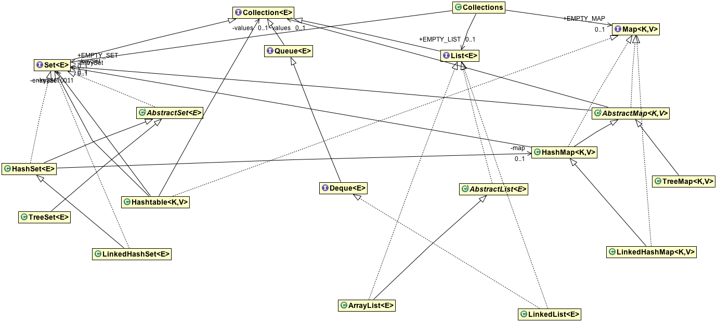

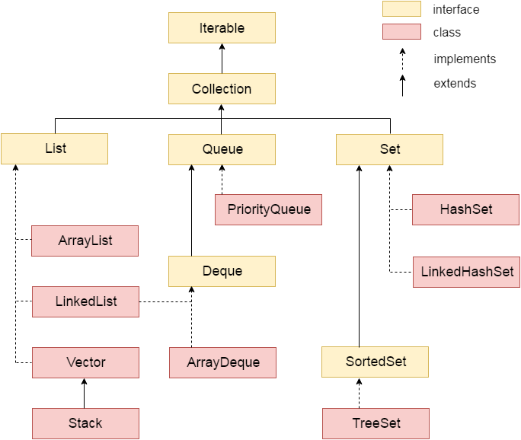
Benefits:
- Reduced Development effort
- Increased Quality
- Reusability and Interoperability
- Reduce effort
Java Collection Interfaces
- Collection Interface - size(), isEmpty(), add(), remove(), clear(), contains()
- Iterator Interface – methods to iterate over collection. Allow caller to remove elements while iterating. Uses Iterator Design Pattern.
- ListIterator Interface – to traverse the list in either direction. Modify the list during iteration and obtain the iterator’s current position in the list.
- Set Interface - Cannot contain duplicate elements. HashSet, TreeSet, LinkedHashSet. It doesn’t allow random access to element in the collection. You can use iterator or for each loop to traverse the elements of a Set.
- List interface – It is ordered collection and can contain duplicate elements. You can access any elements from its index. ArrayList, LinkedList are implementation of List.
- Queue Interface – FIFO (First In First Out) – Head, Tail. Head – remove elements. Tail – elements are added in Tail.
- Deque Interface – support elements insertion and deletion at both ends. Supports capacity-restricted deques as well as those with no fixed size limit.
- Map Interface – It is object that maps keys to values. Cannot contain duplicate keys. Each key can map to at most one value. Has one null key.
- SortedSet Interface – maintains its elements in ascending order.
- SortedMap Interface – maintains its mappings in ascending key order. Ex: dictionaries, Telephone directories.
Java Collections Classes
Java collection framework comes with many implementation classes for interfaces. Most common are ArrayList, HashMap, HashSet. Java 1.5 included concurrent implementations: for example, ConcurrentHashMap, CopyOnWriteArrayList, CopyOnWriteArraySet. Usually collection classes are not thread-safe and their iterator is fail-fast.
- HashSet Class – Implementation of Set interface that is backed by a HashMap. No guarantees for iteration order and permits null element. We can set initial capacity and load factor for this collection. The load factor is a measure of how full the hash map is allowed before its capacity is automatically increased.
- TreeSet Class – A NavigableSet implementation based on TreeMap. The elements are ordered using their natural ordering or by Comparator provided at Set creation time. Guaranteed log(n) time cost for basic operation (add, remove, contains).
- ArrayList Class - Java ArrayList is the resizable-array implementation of the List interface. Implements all optional list operations, and permits all elements, including null. In addition to implementing the List interface, this class provides methods to manipulate the size of the array that is used internally to store the list. (This class is roughly equivalent to Vector, except that it is unsynchronized.)
The size, isEmpty, get, set, iterator, and listIterator operations run in constant time. The add operation runs in amortized constant time, that is, adding n elements requires O(n) time. All the other operations run in linear time (roughly speaking). The constant factor is low compared to that for the LinkedList implementation.

- LinkedList Class – Doubly-linked list implementation of the List and Deque interfaces. Insertion order is maintained. Permit null values.
- HashMap Class – Implementation of Map Interface. It is roughly equivalent to Hashtable except that it is unsychronized and permits null. No guarantee for the order of the map.

- TreeMap Class – A Red-Black tree based NavigableMap implementation. The map is sorted according to the natural ordering of its keys, or by a Comparator provided at map creation time, depending on which constructor is used.
Note that the ordering maintained by a tree map, like any sorted map, and whether or not an explicit comparator is provided, must be consistent with equals if this sorted map is to correctly implement the Map interface. (See Comparable or Comparator for a precise definition of consistent with equals.)

- PriorityQueue class – elements to be processed based on priority. Doesn’t allow null values and its unbounded.

- Collections Class - This class consists exclusively of static methods that operate on or return collections. It contains polymorphic algorithms that operate on collections, “wrappers”, which return a new collection backed by a specified collection, and a few other odds and ends. This class contains methods for collection framework algorithms, such as binary search, sorting, shuffling, reverse etc.
Synchronized Wrappers
Add automatic synchronization (thread-safe) to an arbitrary collection.
public static Collection synchronizedCollection(Collection c);
public static Set synchronizedSet(Set s);
public static List synchronizedList(List list);
public static <K,V> Map<K,V> synchronizedMap(Map<K,V> m);
public static SortedSet synchronizedSortedSet(SortedSet s);
public static <K,V> SortedMap<K,V> synchronizedSortedMap(SortedMap<K,V> m);

Unmodifiable wrappers
Unmodifiable wrappers take away the ability to modify the collection by intercepting all the operations that would modify the collection and throwing an UnsupportedOperationException. It’s main usage are;
- To make a collection immutable once it has been built. In this case, it’s good practice not to maintain a reference to the backing collection. This absolutely guarantees immutability.
- To allow certain clients read-only access to your data structures. You keep a reference to the backing collection but hand out a reference to the wrapper. In this way, clients can look but not modify, while you maintain full access
- public static Set unmodifiableSet(Set<? extends T> s);

Thread Safe Collections
Java 1.5 Concurrent package (java.util.concurrent) contains thread-safe collection classes that allow collections to be modified while iterating. By design iterator is fail-fast and throws ConcurrentModificationException. Some of these classes are CopyOnWriteArrayList, ConcurrentHashMap, CopyOnWriteArraySet.
Collection API Algorithms
- Sorting – reorders a list in ascending order according to an ordering relationship.
- Shuffling – destroys any trace of order that may have been present in a list.
- Searching – searches for a specified element in a Sorted list.
- Composition - The frequency and disjoint algorithms test some aspect of the composition of one or more Collections.
Frequency - counts the number of times the specified element occurs in the specified collection
Disjoint - determines whether two Collections are disjoint; that is, whether they contain no elements in common.
- Min and Max values - The min and the max algorithms return, respectively, the minimum and maximum element contained in a specified Collection
Collection | Ordering | Random Access | Key-Value | Duplicate Elements | Null Element | Thread  Safety
ArrayList | Yes | Yes | No | Yes | Yes | No
LinkedList | Yes | No | No | Yes | Yes | No
HashSet | No | No | No | No | Yes | No
TreeSet | Yes | No | No | No | No | No
HashMap | No | Yes | Yes | No | Yes | No
TreeMap | Yes | Yes | Yes | No | No | No
Vector | Yes | Yes | No | Yes | Yes | Yes
Hashtable | No | Yes | Yes | No | No | Yes
Properties | No | Yes | Yes | No | No | Yes
Stack | Yes | No | No | Yes | Yes | Yes
CopyOnWriteArrayList | Yes | Yes | No | Yes | Yes | Yes
ConcurrentHashMap | No | Yes | Yes | No | No | Yes
CopyOnWriteArraySet | No | No | No | No | Yes | Yes

Difference between Synchronized Collection and Concurrent Collection?
- Both Synchronized and Concurrent Collection provide thread-safety.
- The difference between them comes in performance, scalability and how they achieve thread-safety.
- Synchronized collections like Synchronized Hash Map are much slower than their counterparts. E.g ConcurrentHashMap. The main reason for this slowness is locking;
- In Synchronized – whole collection segment is locked by the current thread and other threads have to wait
- In Concurrent – only the particular segment in collection is locked for read or write operation while other segments are open for other threads. It called lock stripping.

Internal Working of Hash Map
- Hash Map in Java works on hashing principle where hash functions are used to link the key and value in HashMap, Object (Map.entry -> contains both key and value object ) are stored by calling put (key, value) method and retrieved by calling get(key) method.
- When we call put method, the hashcode() method of key object is called which calculates an index of the bucket location where we can store the value object.
- To retrieve, you call the get(key) method and again pass the key object, which lands up at same index or bucket and u retrieve the value object. Bucket default size is 16.
- If two different key returns the same index then collision occurs in this case, a linked list is formed at that bucket location and a new entry is stored as next node.
- Now put method will just append the object nodes in the linked list
- But in case of get method if we have a linked list at that bucket location then we need an extra check to check search the correct value, this is done by equals() method. It checks every key of every node and if equals() return true then the Map return that corresponding value from the linked list.
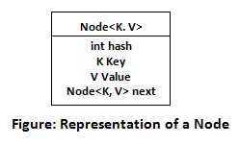

Java 8 changes done in HashMap
If Hashcode not implemented properly and all the keys are stored at particular bucket then the linked list size is increased and the lookup time of Hashmap increases from O(1) to O(n).
- The alternative String hash function added in Java 7 has been removed
- Buckets containing a large number of colliding keys will store the entries in a balance tree instead of linked list after certain threshold reached.
Above Changes ensure performance of O(Log( n)) in worst case scenarios and O(1) with proper hashcode().

Ways to iterate the elements of the collection in Java
There are various ways to traverse the collection elements:
- By Iterator interface.
- By for-each loop.
- By ListIterator interface.
- By for loop.
- By forEach() method.
- By forEachRemaining() method.

Spliterator in Java8
Java Spliterator is an interface in java Collection API which is introduced in Java 8. It supports parallel processing. Its used to traverse the elements both sequentially & Parallelly.
tryAdvance() – used to iterate elements individually in multiple Threads to support parallel processing.
foreachRemaining() – Used to iterate elements sequentially in a single thread. Same like foreach() method.
trySplit() – to divide itself into Sub-Spliterators to support parallel processing. The original list split into two different with equal size.
- int characteristics(): Returns a set of characteristics of this Spliterator and its elements.
- long estimateSize(): Returns an estimate of the number of elements that would be encountered by a forEachRemaining() traversal, or returns Long.MAX_VALUE if infinite, unknown, or too expensive to compute.
- default void forEachRemaining(Consumer action): Performs the given action for each remaining element, sequentially in the current thread, until all elements have been processed or the action throws an exception.
- default Comparator getComparator(): If this Spliterator’s source is SORTED by a Comparator, returns that Comparator.
- default long getExactSizeIfKnown(): Convenience method that returns estimateSize() if this Spliterator is SIZED, else -1.
- default boolean hasCharacteristics(int characteristics): Returns true if this Spliterator’s characteristics() contain all of the given characteristics.
- boolean tryAdvance(Consumer action): If a remaining element exists, performs the given action on it, returning true; else returns false.
- Spliterator trySplit(): If this spliterator can be partitioned, returns a Spliterator covering elements, that will, upon return from this method, not be covered by this Spliterator.

Spliterator Characteristics
It has eight different characteristics that describe its behavior. Those can be used as hints for external tools:
- SIZED – if it's capable of returning an exact number of elements with the estimateSize() method
- SORTED – if it's iterating through a sorted source
- SUBSIZED – if we split the instance using a trySplit() method and obtain Spliterators that are SIZED as well
- CONCURRENT – if source can be safely modified concurrently
- DISTINCT – if for each pair of encountered elements x, y, !x.equals(y)
- IMMUTABLE – if elements held by source can't be structurally modified
- NONNULL – if source holds nulls or not
- ORDERED – if iterating over an ordered sequence

Can you use any class as a Map Key?
- The class overriding the equals() method must also override the hashcode() method
- The class should adhere to the rules associated with equals() and hashcode() for all instances
- The class filed which is not used in equal() method should not be used in hashcode() method as well
- The best way to use user-defined key class is making it immutable. It helps in catching the hashcode() for better performance. Also if the class is immutable it will ensure that the hashcode() and equals() method are not changing in the future.

Big O Complexity Cheat Sheet

Ref: https://gist.github.com/marcinjackowiak/85f144d0f1ed5fd066d4d2a34961497c
Complexity (Best to Worst)
===================================================================================================
O(1) < O(log n) < O(n) < O(n log n) < O(n^2) < O(2^n) < O(n!)
Collections
===================================================================================================
List | Add | Remove | Get | Contains | Next | Data Structure
---------------------|------|--------|------|----------|------|---------------
ArrayList | O(1) | O(n) | O(1) | O(n) | O(1) | Array
LinkedList | O(1) | O(1) | O(n) | O(n) | O(1) | Linked List
CopyOnWriteArrayList | O(n) | O(n) | O(1) | O(n) | O(1) | Array
Set | Add | Remove | Contains | Next | Size | Data Structure
----------------------|----------|----------|----------|----------|------|-------------------------
HashSet | O(1) | O(1) | O(1) | O(h/n) | O(1) | Hash Table
LinkedHashSet | O(1) | O(1) | O(1) | O(1) | O(1) | Hash Table + Linked List
EnumSet | O(1) | O(1) | O(1) | O(1) | O(1) | Bit Vector
TreeSet | O(log n) | O(log n) | O(log n) | O(log n) | O(1) | Red-black tree
CopyOnWriteArraySet | O(n) | O(n) | O(n) | O(1) | O(1) | Array
ConcurrentSkipListSet | O(log n) | O(log n) | O(log n) | O(1) | O(n) | Skip List
Queue | Offer | Peek | Poll | Remove | Size | Data Structure
------------------------|----------|------|----------|--------|------|---------------
PriorityQueue | O(log n) | O(1) | O(log n) | O(n) | O(1) | Priority Heap
LinkedList | O(1) | O(1) | O(1) | O(1) | O(1) | Array
ArrayDequeue | O(1) | O(1) | O(1) | O(n) | O(1) | Linked List
ConcurrentLinkedQueue | O(1) | O(1) | O(1) | O(n) | O(n) | Linked List
ArrayBlockingQueue | O(1) | O(1) | O(1) | O(n) | O(1) | Array
PriorirityBlockingQueue | O(log n) | O(1) | O(log n) | O(n) | O(1) | Priority Heap
SynchronousQueue | O(1) | O(1) | O(1) | O(n) | O(1) | None!
DelayQueue | O(log n) | O(1) | O(log n) | O(n) | O(1) | Priority Heap
LinkedBlockingQueue | O(1) | O(1) | O(1) | O(n) | O(1) | Linked List
Map | Get | ContainsKey | Next | Data Structure
----------------------|----------|-------------|----------|-------------------------
HashMap | O(1) | O(1) | O(h/n) | Hash Table
LinkedHashMap | O(1) | O(1) | O(1) | Hash Table + Linked List
IdentityHashMap | O(1) | O(1) | O(h/n) | Array
WeakHashMap | O(1) | O(1) | O(h/n) | Hash Table
EnumMap | O(1) | O(1) | O(1) | Array
TreeMap | O(log n) | O(log n) | O(log n) | Red-black tree
ConcurrentHashMap | O(1) | O(1) | O(h/n) | Hash Tables
ConcurrentSkipListMap | O(log n) | O(log n) | O(1) | Skip List
Sorting
===================================================================================================
Algorithm | Best | Average | Worst | Space Complexity
---------------|--------------|--------------|--------------|------------------
Quicksort | O(n log n) | O(n log n) | O(n^2) | O(log n)
Mergesort | O(n log n) | O(n log n) | O(n log n) | O(n)
Timsort | O(n) | O(n log n) | O(n log n) | O(n)
Heapsort | O(n log n) | O(n log n) | O(n log n) | O(1)
Bubble Sort | O(n) | O(n^2) | O(n^2) | O(1)
Insertion Sort | O(n) | O(n^2) | O(n^2) | O(1)
Selection Sort | O(n^2) | O(n^2) | O(n^2) | O(1)
Tree Sort | O(n log n) | O(n log n) | O(n^2) | O(n)
Shell Sort | O(n log n) | O(n log^2 n) | O(n log^2 n) | O(1)
Bucket Sort | O(n+k) | O(n+k) | O(n^2) | O(n)
Radix Sort | O(nk) | O(nk) | O(nk) | O(n+k)
Counting Sort | O(n+k) | O(n+k) | O(n+k) | O(k)
Cubesort | O(n) | O(n log n) | O(n log n) | O(n)

